Quabbin Reservoir Lesson Plan Note Catcher

Look at the picture below. Record your thoughts below. What do you…

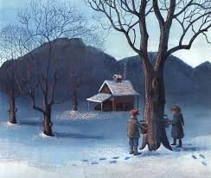

See | Feel
Know | Wonder

