Tiles that will be used LESS often, print less copies:

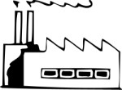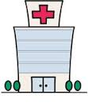
Factory Hospital

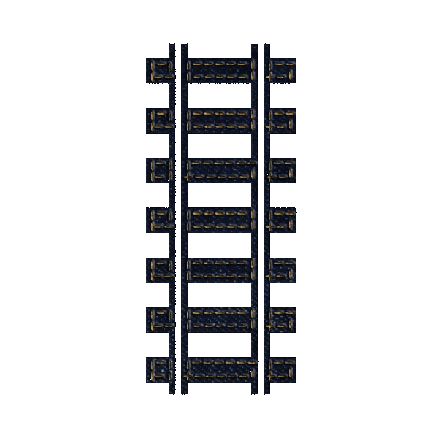
School Railroad

Factory Hospital

School Railroad

Ones that will be used MORE often, print MORE times:

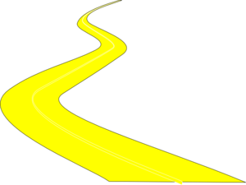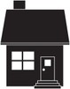
River Road House

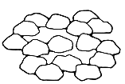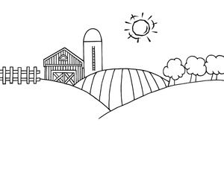
Stone Forest Farm for food

River Road House

Stone Forest Farm for food

Lake Lake

